Little Malvern Quarry Grid Ref: SO 76974124
The land in which this quarry is located was part of a large estate at Little Malvern owned firstly by Little Malvern Priory in the 12th century and shortly after the Dissolution of the Monasteries in 1536-8, the Crown sold the estate to Henry Russell whose descendants own it today.

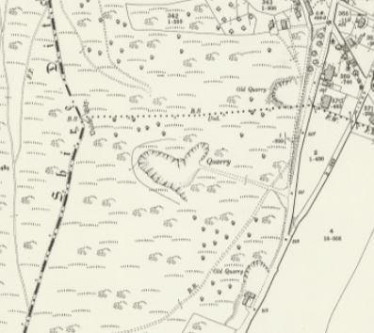
OS Map 25” to the mile 1905 showing location of the quarry to the west of the Wells Road

Charles Berington, a descendant of the Russell family and owner of the Little Malvern estate, must have been aware of the potential riches to be had from his land when he leased a farm to George Higgins in 1862 with the clause ‘C M Berington to have liberty to search for mines, materials and quarries and to carry away the produce thereof’. By the 1860’s a small quarry had opened on the eastern slopes of the Malvern Hills just south of the Holy Well at Little Malvern supplying both Malvern and Upton Urban District Councils with broken stone for the repair of local roads. To help bring the stone down to the Wells Road in the 1880’s, Charles Berington installed a rope-worked narrow gauge tramway. At that time quarrying was a seasonal occupation carried out mainly by estate or hired-in workers. This is confirmed by Mr Thorpe, Surveyor to MUDC, who reported that when he commenced his employment in 1904 the output from the quarry was negligible and for many months of the year the quarry was not worked at all.
The chief aim of the Malvern Hills Act of 1884 was to stop any further encroachment on the Hills. However, one of the unfortunate side effects of the passing of this Act was that it unwittingly confirmed that it was the landowners who held the legal right to exploit any mineral assets, a situation which at best had previously been hazy. Whilst quarrying remained on a small scale, mineral ownership had not been an issue, but as mechanisation began to be employed it became increasingly possible to exploit the mineral wealth in large quantities.
Large scale quarrying at Little Malvern began in 1906/7 when Charles’ son William Berington leased the quarry to Alfred Creed and his financial backer, Frank Hudson. Creed already owned a stone quarry at Chudleigh in Devon, and had previously been Stone Quarry Manager at Tytherington, Glos. He came to Malvern specifically to quarry granite roadstone on a commercial basis to satisfy the increasing demand for new and better roads for the newly emerging motor traffic. And, of course, profit. Initially he operated under the name Little Malvern Granite Quarry Company, which in 1909 was incorporated in the name of Pyx Granite Company Limited.

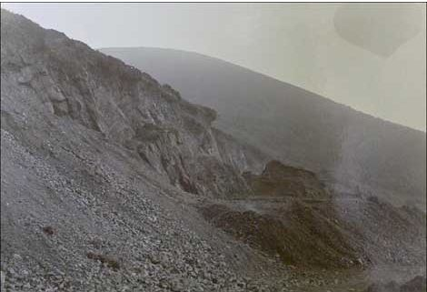
Courtesy BBC Hereford & Worcester – Photo dated 1901 – Before large scale quarrying commenced

Due to the quarry being some 300 feet above the main Wells road, Pyx Granite had to invest huge amounts of money into the basic infrastructure – see outline map below. They brought in a railway which possessed a substantial self-acting double track incline of about 200 yards in length, which was constructed to convey stone down from the quarry to a crushing plant sited alongside the main road below. The tracks passed on either side of the winding drum, the base of which, some 6 feet square, remains today. The lines then joined to make a rail section and passed through a narrow cutting, after which they separated to form a conventional two track incline. At the foot of the incline the rails curved very sharply past a stone retaining wall. In addition, two narrow-gauge lines on different levels were built from the crushing plant to waste tips on the south side of this plant which ran for about 150 yards.

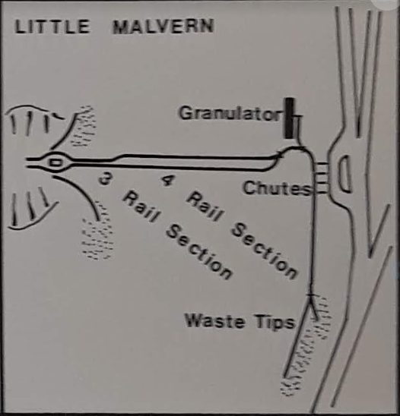

Courtesy – Industrial Railway Record

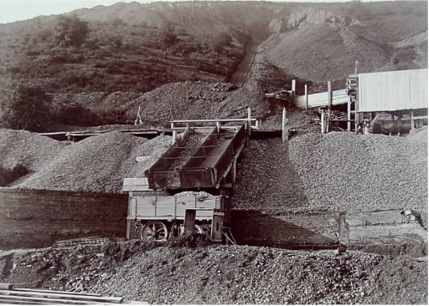
Courtesy – Malvern Hills Trust and Railways in Worcestershire
This photograph shows the incline clearly descending from the quarry at the top of the hill. A modern stone crushing plant has been built on the right hand side of the incline. Two metal chutes lead from the higher level into the wooden road wagon. The Malvern Hills Conservators archivist states that this photograph (that is accredited to H E Dougherty on the original) was taken for use in connection with the Malvern Hills Act 1909.

As soon as the quarry was commercially operational, the Evesham Standard reported in March 1907 that the ‘County Council (had) passed a motion to appoint a committee to inquire into the nuisance, if any, caused in Malvern Wells and Little Malvern by the working of the quarry at Little Malvern, the damage done to the roads and (the) nuisance caused by traction engines and trucks used in connection with the quarry’. This was followed in July of that year by Upton Urban District Council receiving a letter from Mr W J Farthing, secretary to the Little Malvern Quarry Protest Committee, stating that ‘the working of the stone-crushing machinery at the quarry was an intolerable nuisance to the surrounding residents and owners of property. Iron shoots for the stones not only aggravated the nuisance but were a serious danger to the public using the high road. Further, the heavy engines used for the stone traction traffic at unreasonable hours were an interference with the rights of the public’. At the same meeting it was reported that although the quarry ‘had been used for 50 years it was only since a Limited Company took it and broke stone by heavy machinery that the nuisance had been marked’.
Not only were the quarry workings causing nuisance, the traction engines were also under the spotlight. Again in July 1907, the Evesham Standard reported on the case which came before Malvern Magistrates whereby Thomas Parry, driver of a motor engine belonging to the Little Malvern Granite Quarry Company, appealed against a fine of 10/- with £1 3/6d costs for using a locomotive on a highway not consuming, as far as practicable, its own smoke.
The quarry was in the news again in March 1908 when the Alcester Chronicle reported that the County Council Highways and Bridges committee needed to strengthen 600 yards of road from the junction of the Malvern Wells main road and Green Lane to enable it to bear heavy traction engine traffic, the cost of which was estimated at £500 and they were to ask the owners of Little Malvern Quarry to supply (stone) free of charge as they had done previously. It was pointed out that it was not the quarry owners who were responsible for the destruction of the roads but the hauliers – a moot point.

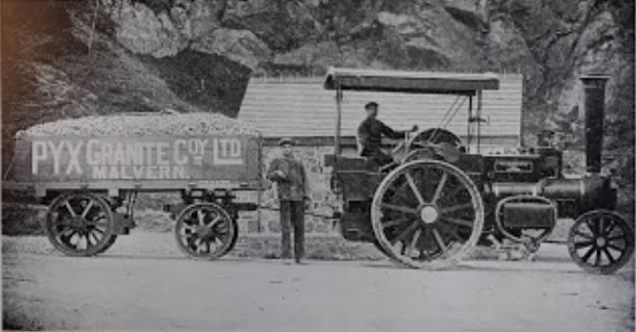

In December 1909, a new lease was negotiated whereby Pyx Granite Co. Ltd. of Little Malvern took a 21 year lease on a stone quarry called Little Malvern Quarry on Malvern Hills, to hold from 29th September 1909 at an annual rent of £30. This included royalties of the first 360 yards at 4d per yard, second 360 yards at 3d and third 360 yards at 2d for First Class stone with all Second Class stone and waste at 1d per yard.
1909 was also a busy year for the Malvern Hills Conservators when they sought to secure another Act of Parliament to bring all quarrying on the Hills to an end. They knew they would have to buy the manorial rights from the Lords of the Manors and the Act would allow them to raise funds from the local rates in order to do this. In response to the Act, some of the landowners handed over their rights without a fuss whilst others held out. The Conservators were particularly concerned about 12 quarries which they annotated on a map which accompanied the application for the Act. In the extract below, Little Malvern Quarry is No.1.

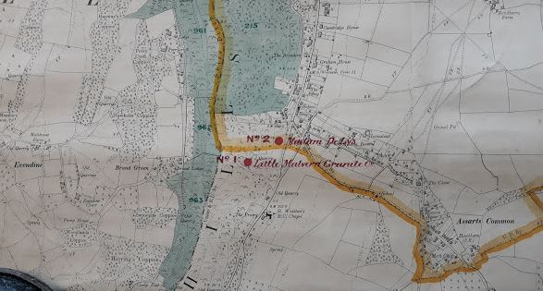
Courtesy Worcestershire Archives – BA 9196

The Conservators estimated it would cost £4565 to buy the mineral rights from William Berington, based on a figure of 20,000 tons at 4d over 25 years plus 10%. They would also have to compensate Pyx Granite in order for them to relinquish their lease which was due to expire on 29.09.1930. For this they calculated a total of £6875, £3500 for plant and machinery plus profit on 15,000 tons at 1/6d per year for 3 years, £3375. The total for one quarry alone was £11440, a huge sum. It was estimated that £100,000 would be needed to buy out all the quarries, a sum which was totally out of reach for the Conservators.
Another event which was to take place in 1909 at this quarry was the death of Miss Mildred Blanche Trethewy of Newquay, Cornwall, who tragically fell to her death in the quarry.

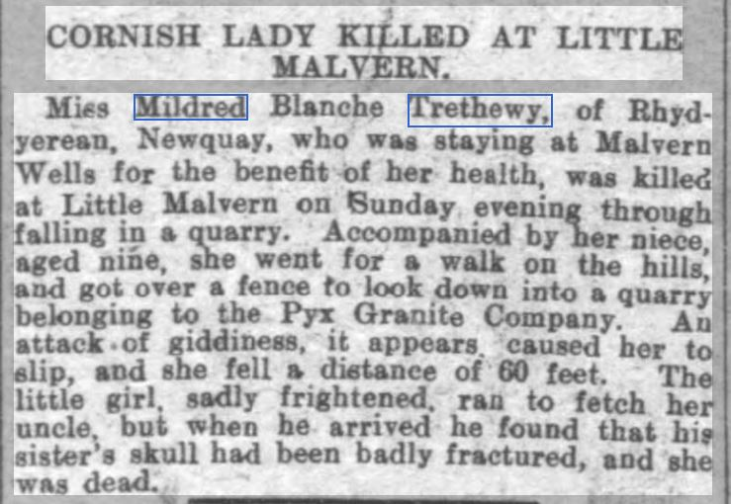
Gloucestershire Chronicle 8th May 1909
This was not the only fatal accident at the quarry. In July 1911 John Jinnifer, a 55 year old quarryman from Welland, was killed whilst he worked. The report below gives a vivid account of the working conditions of the quarrymen and the lack of health and safety considerations.
Worcester Journal reported:-
“He (Jinnifer) had been in the employ of the company for several years and was held in high esteem. Alice Jinnifer, daughter of the deceased, said he was a labourer in the employ of the Pyx Granite Company and was 55 years of age. He left home at 5 o’clock to go to his work at the quarry at Little Malvern. At 8.30 am her brother came and told her that deceased was seriously hurt.
George Gill, foreman in the employ of Pyx Granite Co. stated that he set the deceased to work on Friday, his duty was ‘barring out’ stone with an iron bar. Witness heard of the accident at 7.30 am five minutes after it occurred. Witness asked deceased if he was hurt much and Jinnifer put his hand on his stomach but made no reply. Dr. Nugent Smith, who was called, ordered the removal of the deceased to hospital where he was attended by Dr. Cowan. ‘Barring out’ was the daily work of the deceased who had been at the quarry over 5 years. He was a careful and experienced man.

The Coroner: “He did not run any unnecessary risks did he – he did to some extent”
“I suppose he had to, at that work – Yes”
“Did you particularly notice this place – I thought it was quite safe”
In reply to further questions witness said the face of stone above the deceased, at the spot where he was working, was 13 feet high and he was about 13 feet from the ground. He had plenty of standing room.
Charles Baldwin, labourer, said he was working with the deceased on Friday morning and saw deceased drying to prize some stone with a bar. Witness heard the bar drop and on looking round saw deceased fall. He rolled over once or twice and stone went over him when he was down. Witness went to his assistance and helped to carry him outside the quarry. He said he was hurt very badly. Deceased was standing on a slope when the accident occurred.
By the Inspector (Of Mines): Almost 5 cwt of stone came from the face and it broke into small pieces. He could not say whether deceased slipped or was knocked down by the stone.
Questioned by the Coroner, witness said that the heaviest piece of stone that rolled over the deceased was not more than half a hundredweight. It was a safe place to work.
The jury returned a verdict of ‘Accidental death’.

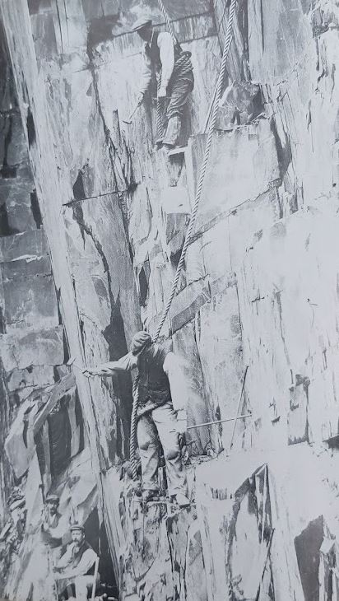

The problem of getting stone out of the quarry and on its way to the customer constantly caused problems for the County Council’s Highways and Bridges department. In 1912, the Evesham Standard reported on the excessive damage to the road from Little Malvern Quarry to the railway station at Malvern Wells caused by traction engines. The road was inspected and a full inquiry was held with a view to making by-laws to restrict locomotive traffic. At Malvern Wells it was suggested that traffic from the quarry be diverted to an alternative route. This however, never came to fruition. The cost of strengthening and repair amounted to £4614 with an additional amount of £1550 being spent on the Hanley Castle road leading to the Midland Railway Station at Malvern Wells. County and District Councils continued to keep the roads in reasonable repair as far as their budget would allow.
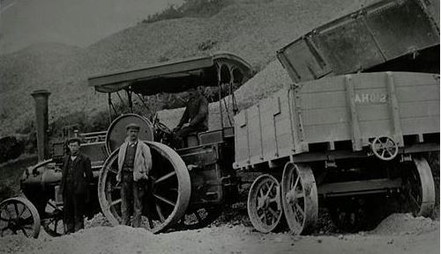
Traction engine at Little Malvern Quarry c1912
Commercial quarrying continued apace all around the Hills until the early 1920’s when the Conservators put together yet another application for a more empowering Act of Parliament. The Act was finally passed in 1924 and gave the Conservators the authority to compulsorily purchase the whole or any portions of the lands, properties, quarries, manorial rights (including mineral rights) and interests of specified areas of land over the next five years to prevent further land use for quarrying. Whilst the aim of the Act was to save the beauty of the Hills and protect them from the threat of quarrying, quarry owners had vested rights of quarrying which they claimed could not be taken away from them without compensation. The Conservators were given five years to raise the necessary loans to enact the purchases.
As a consequence of this Act, negotiations took place between Pyx Granite (who also quarried on North Hill), Malvern Hills Conservators and Malvern Hills Urban District Council. The results of these negotiations for Pyx Granite were:-
- Their lease for Little Malvern Quarry would not be renewed when it expired on 29.09.1930. William Berington would sell the minerals rights to Malvern Hills Conservators for £8955.
- An extension to the existing lease of North Quarry, but for the lower slopes only, would be permitted with a final expiry date of 24.06.1960 which could not be renewed.
- Malvern Urban District Council was to grant a lease to Pyx Granite for the lower slopes of their own quarry on North Hill which would also expire on 29.09.1960.
- Pyx Granite were permitted to continue quarrying on their own freehold land at Tank Quarry.
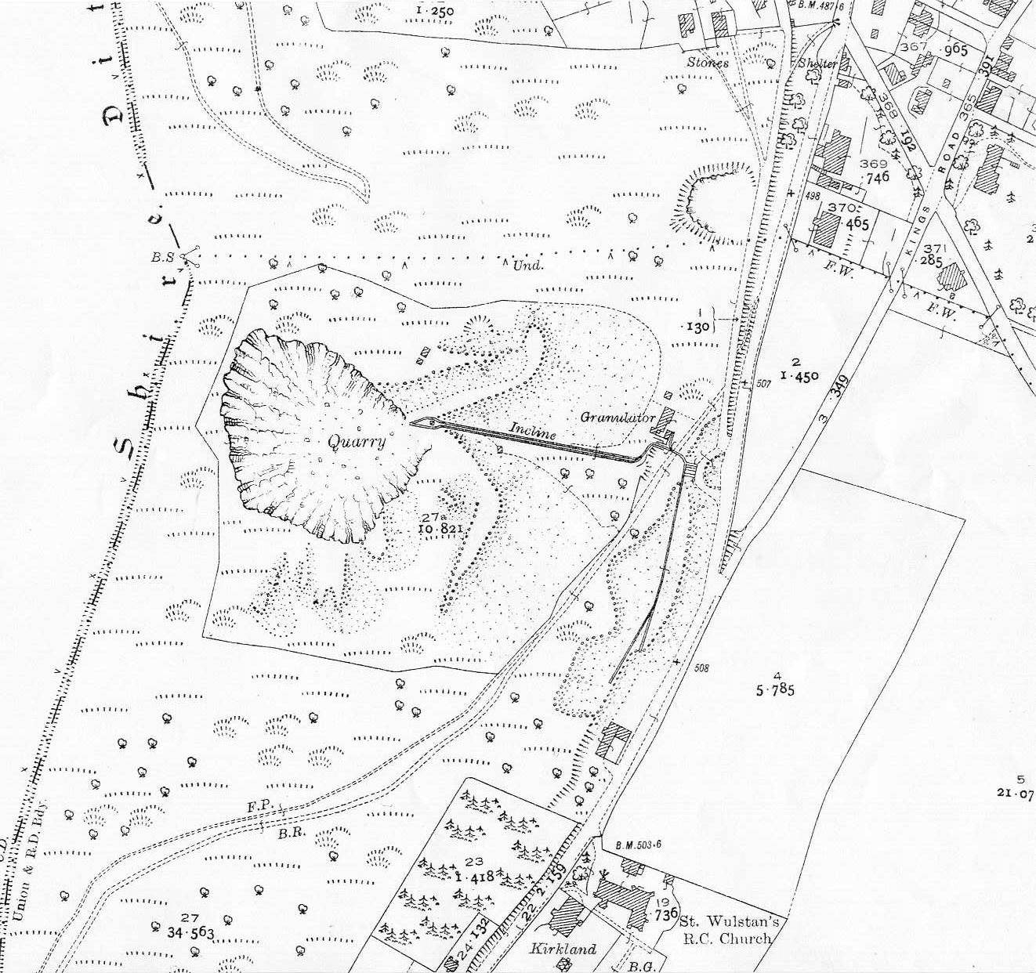
OS Map 1927 showing tramway, quarry buildings and waste stone piled up to either side of the tramway.
The photograph below shows a scene not too dissimilar to the photograph above but here the site is neglected. The photograph is reputed to have been taken c1923 by the Conservators in support of the 1924 Act, but perhaps it was taken after 1930 when all quarrying here had stopped.
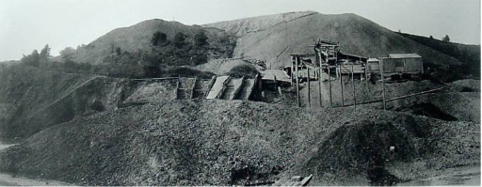
The Conservators Ranger was given the job of tidying up the site and selling the stone chips and sand which remained after the closure, reporting in May 1933 that he had collected £351 7/- from the sales out of Little Malvern, West of England and Gardners quarries.

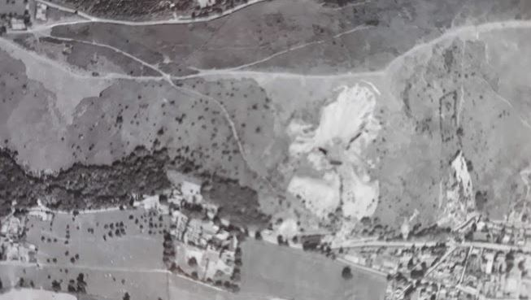
Aerial photo 1946 – Courtesy Historic England Quarrying came oh so close to the skyline

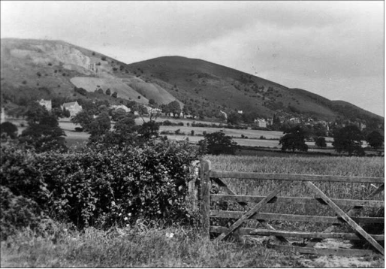
This photograph was probably taken in the mid-1930’s after the quarry had closed. The quarry is high up on the hill, top left in photo.
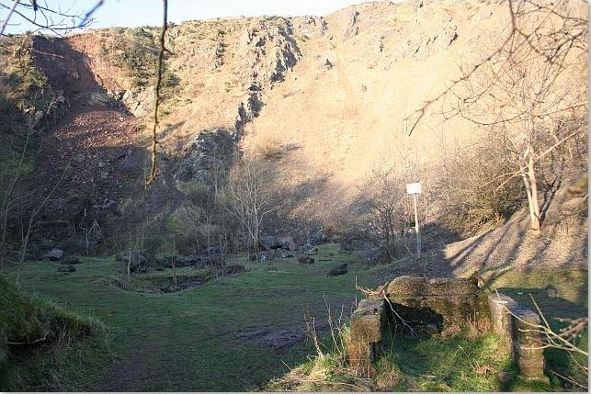
Little Malvern Quarry photo showing recent landslide on extreme left

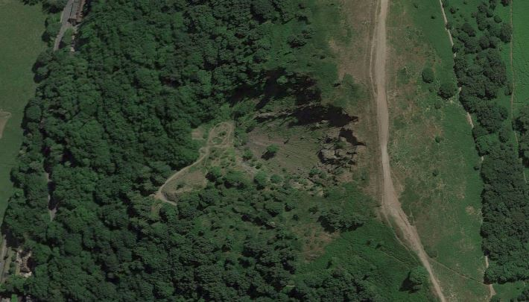
Google Earth 2019

And finally. After the closure of the quarry much of this site remained in the hands of the Little Malvern estate until November 2002 when, after being advertised for sale, it was purchased by the Malvern Hills Conservators.

